Three key things to se up database

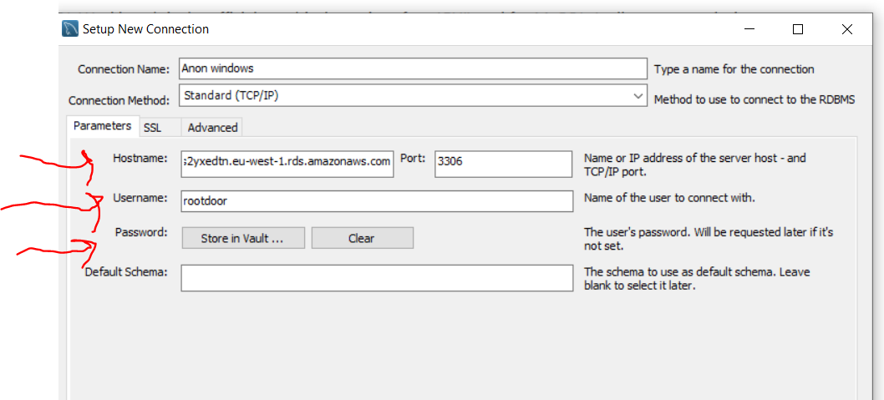

Now let us break this Duncan code and figure out this join shit.

SELECT ID, ActionID, Roles, Location, Interaction, PageObjectForAction, ResultFromAction, Timestamp, UserID, FirmIDForUser, FirmIDForAction, FundIDForAction, UniqueCodeForAction

FROM door.activitytracking

JOIN door.activitymetadata ON door.activitytracking.ActionID = door.activitymetadata.ActivityMetaDataId

ORDER BY ID DESC;

Now first of all let us see the table for activity tracking

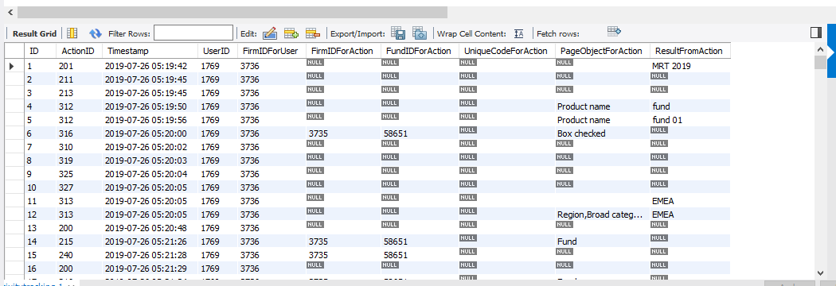

It has no location and has no role.

When we do

SELECT \* FROM door.activitymetadata;

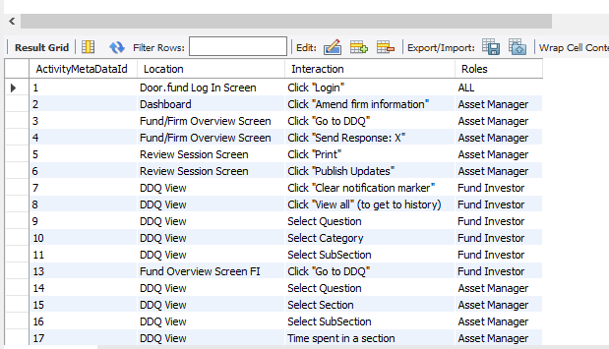

Has role but no timestamp

Now when we do

SELECT\*FROM door.activitytracking

JOIN door.activitymetadata

;

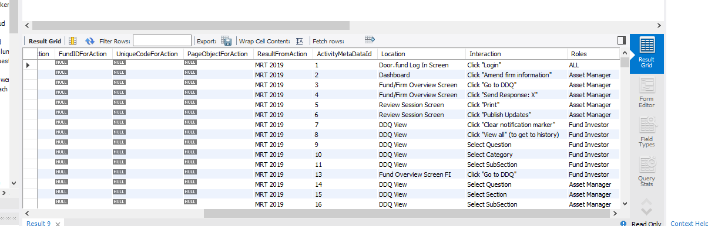

It has timestamp, location and role.

Now to summarise it

You could have just done SELECT \*

FROM door.activitytracking.

But he didn’t he decided to specify the columns he wanted.

SELECT ID, ActionID, Roles, Location, Interaction, PageObjectForAction, ResultFromAction, Timestamp, UserID, FirmIDForUser, FirmIDForAction, FundIDForAction, UniqueCodeForAction

FROM door.activitytracking.

Now take note….if he ran the sequel, it would have failed because it has no role. That was why he joined both columns and from the join…… he is saying select those specific ones.

Now there is a formular for this…..

SELECT \*

FROM [table1]

JOIN [table2] ON [column1] = [column2];

Now lets break this down

Table 1 is the first table you select \* from

Table 2 is the table you want to join it to.

Now even though you done a select \* you still need to tell the compiler what you want hence ou put that table ON (table 1.column1) basically the first table .first columns = table 2. First column2) .

Then finally order by ID desc;

SELECT ID, ActionID, Roles, Location, Interaction, PageObjectForAction, ResultFromAction, Timestamp, UserID, FirmIDForUser, FirmIDForAction, FundIDForAction, UniqueCodeForAction

FROM door.activitytracking

JOIN door.activitymetadata ON door.activitytracking.ActionID = door.activitymetadata.ActivityMetaDataId

ORDER BY ID DESC;